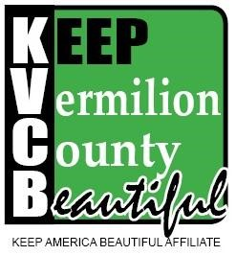

Keep Vermilion County Beautiful 2022 Invoice
Vermilion County’s “best kept secret” for teaching individual responsibility for community environments.

Membership Levels
Corporate $1000 and above
A Corporate Membership will include an opportunity for two (2) to join the Board of Directors, an opportunity to apply for a Beautification Grant, recognition on our website, recognition at all KVCB Events, and assistance with one (1) Community Event of your choice within one (1) calendar year.
Business $150 and above
A Business Membership will include an opportunity for 1 representative to join the Board of Directors, an opportunity to apply for a Beautification Grant and recognition on our website.
Church $100 and above
A Church Membership, for local community churches, will include an opportunity for 1 representative to join the Board of Directors and apply for a Beautification Grant.
Neighborhood Association $100 and above
A Neighborhood Association Membership, for local neighborhood associations, will include an opportunity for 1 representative to join the Board of Directors and apply for a Beautification Grant.
Residential $50 and above
A Residential Membership will include an opportunity for 1 to join the Board of Directors and apply for a Residential Beautification Grant.
Honor $250 and above
An Honor Membership will allow you to honor someone who is or has been a loyal supporter of KVCB. The honoree will be placed on the Honor Roll on our website.

Amount Enclosed $_____________________
Organization / Name:__________________________________________________________
Contact Person:_______________________________________________________________
Mailing Address:_______________________________________________________________
City:________________________________________ State:___________ Zip:____________ Phone:_____________________________ Email:____________________________________
Please make all checks payable to: Keep Vermilion County Beautiful.
Attn: Brenda Adams, Executive Director
Keep Vermilion County Beautiful
PO Box 643
Danville, Illinois 61834-0643

